**SPRINT 1**

**ENVIRONMENTAL SETUP**

|  |  |
| --- | --- |
| Date | 29 October 2022 |
| Team ID | PNT2022TMID22996 |
| Project Name | Plasma Donor Application |

**FLASK SETUP:**

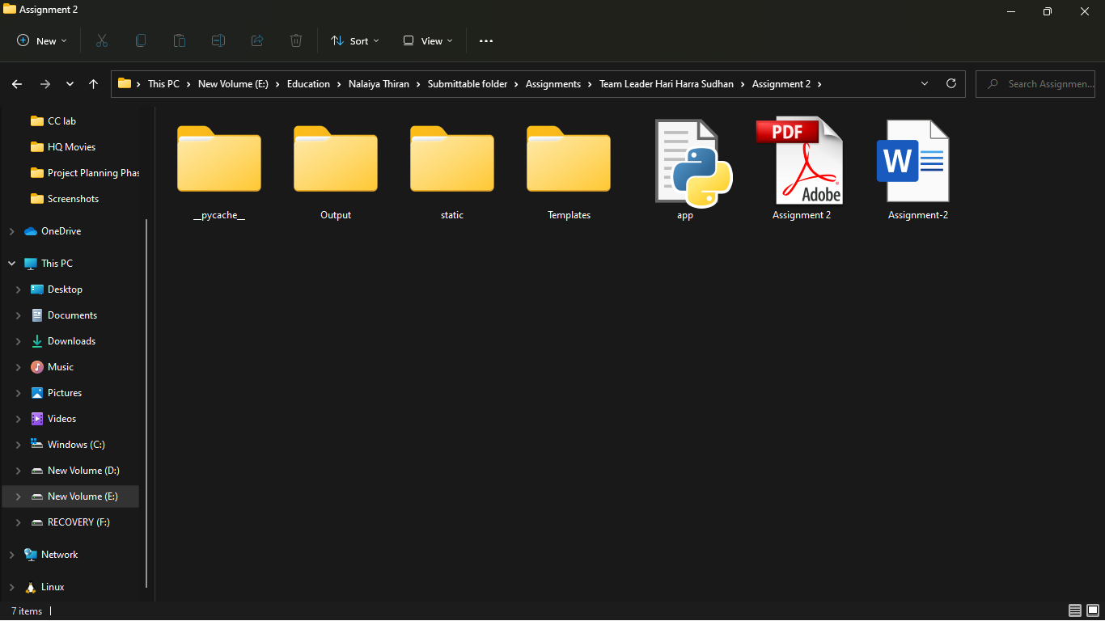

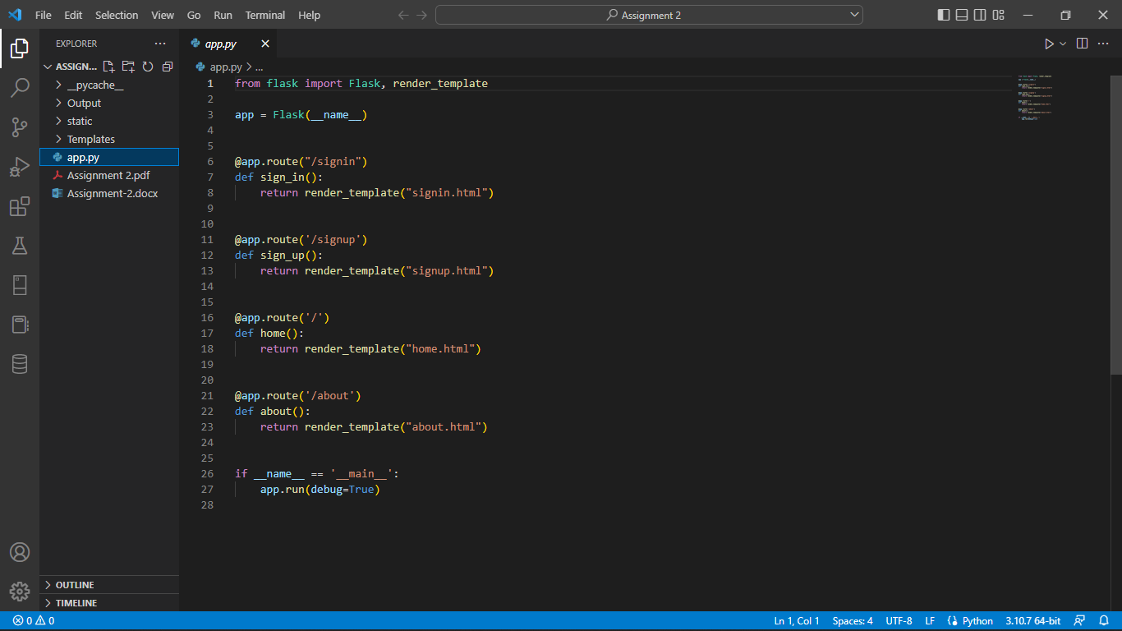

**DOCKER CLI SETUP:**

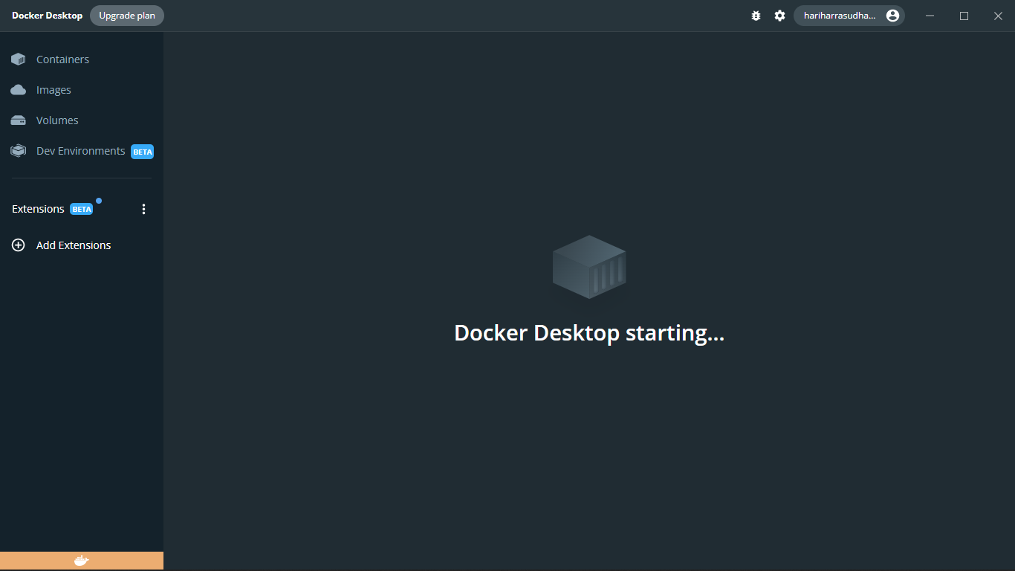

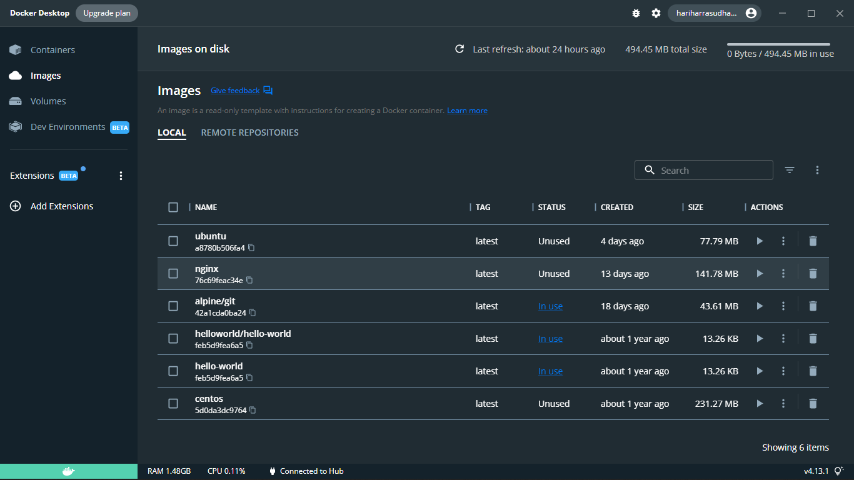

**CLOUD ACCOUNT CREATION:**

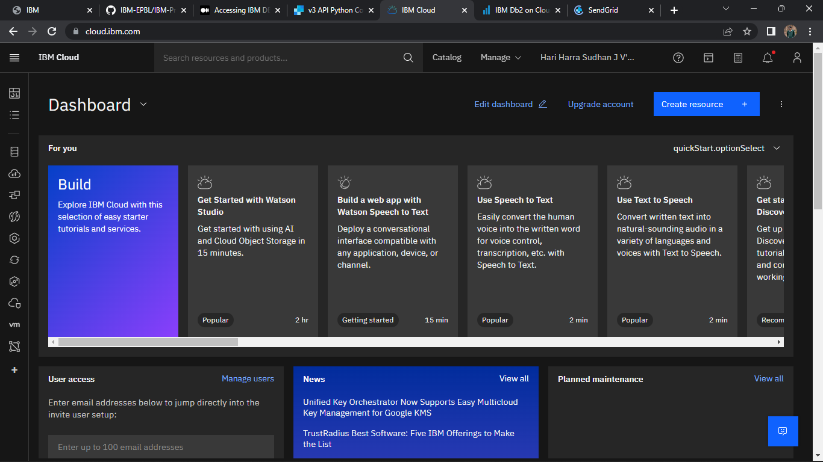

**SENDGRID ACCOUNT CREATION:**

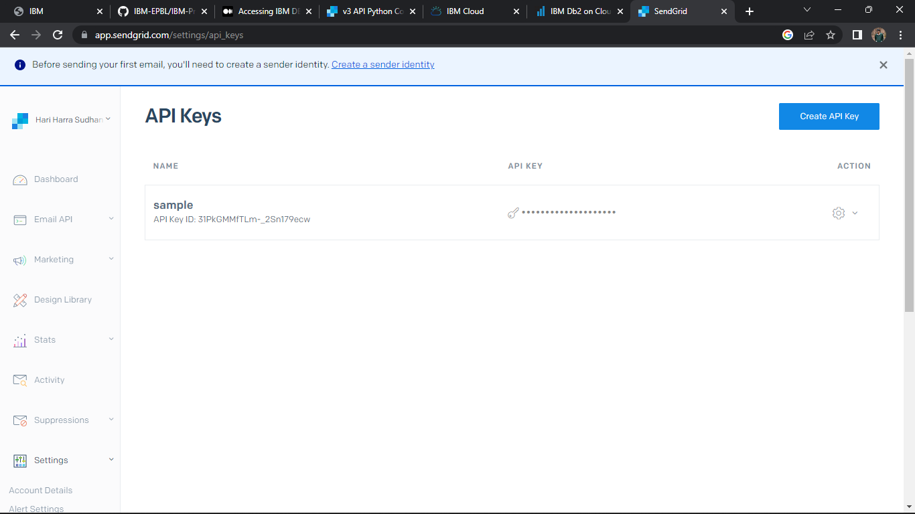

**IBM CLOUD CLI:**

